Summary Sausage Factory Presentation

Brand History
The company was founded in 2000 as a privately owned company, with a focus on production and marketing of meat products.
It is a company with a clear global mission, with policies and strategies on medium and long term, considering both technological modernization, product processing in accordance with the EC rules of food safety and a continuous search for healthy products that can provide to consumer an improvement of their quality of life, a balance between the pleasure of eating well and healthy eating.
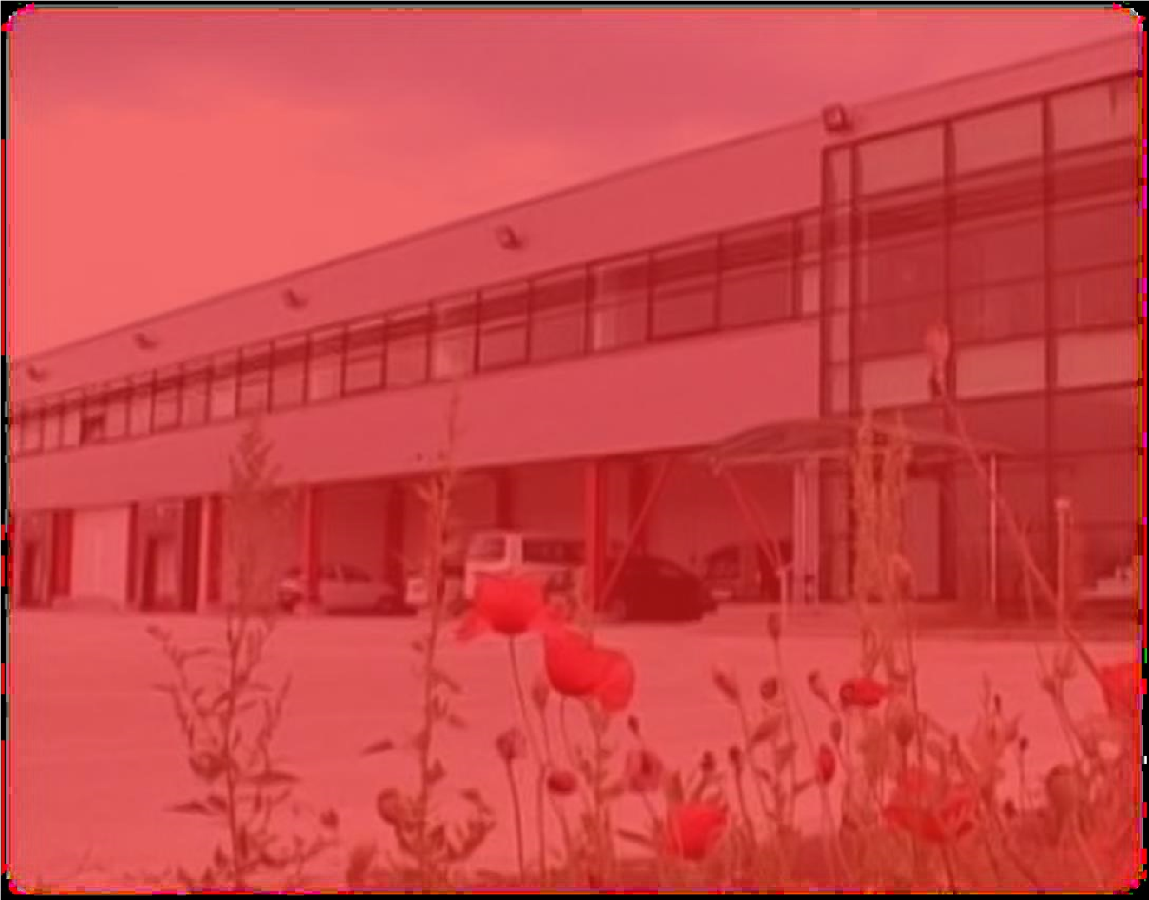

Brand Values
The company was founded in 2000 as a privately owned company, with a focus on production and marketing of meat products.
It is a company with a clear global mission, with policies and strategies on medium and long term, considering both technological development, product processing in accordance with the EC rules of food safety and a continuous search for healthy products that can provide to consumers an improvement of their quality of life, a balance between the pleasure of eating well and healthy eating.
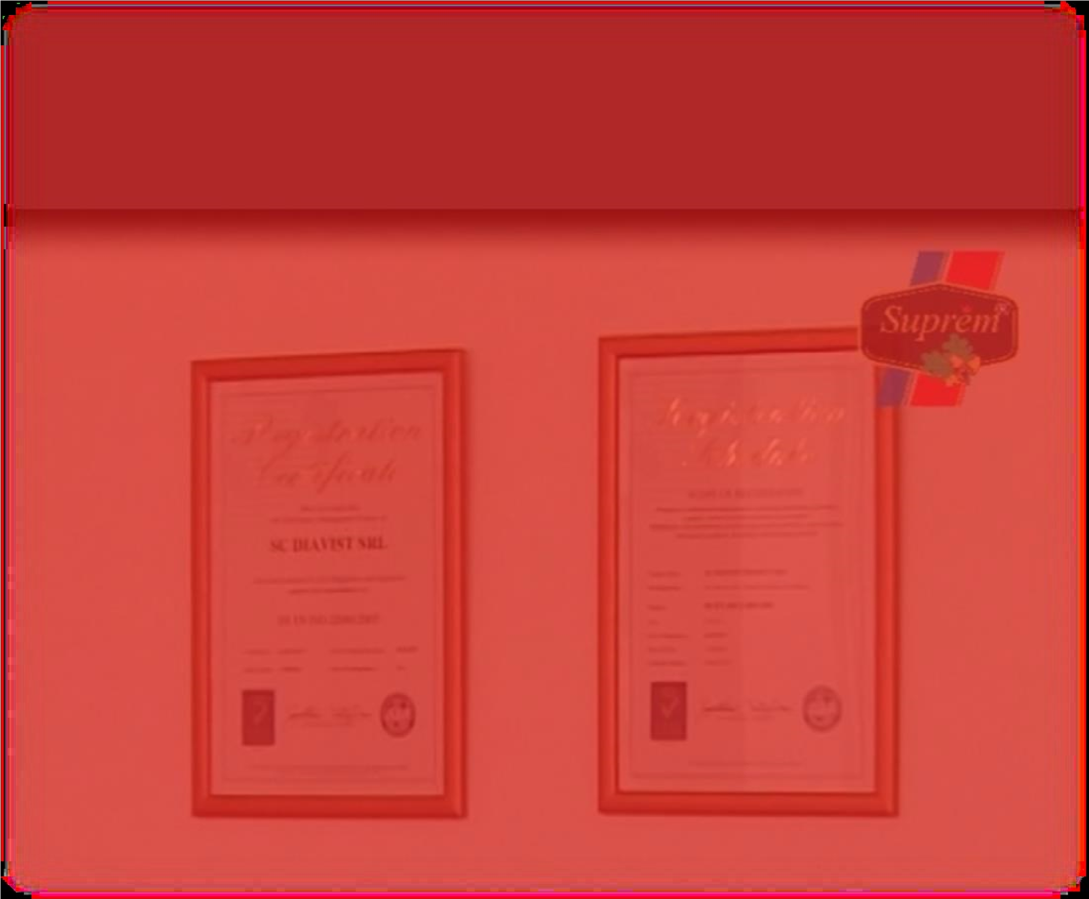

Equipment and Capacity
The new factory is the result of an investment project with SAPARD funds, carried out in 2006. The pro-

ject took into account the achievement in compliance with EU standards of production flows, buildings, utilities, equipment and tools specific to the meat processing industry.
Together with existing facilities and equipment at the date of proceeding with the investment, the current production capacity of the factory is around 20 Tons cold cuts/day, the factory having a total usable area of approximately 3.450 sq.

Portfolio
Our product range include various types of deli meat and vegetable specialties main-stream 62% and low-

coast 38%

Bologna
Sausage

Boiled &
Smoked

Boiled & Smoked
Specialties

Smoked & Fresh

Sausages

Salamis &
Vegetables
Pates

Hot Dogs

Developing Portfolio

Current products are delivered in bulk, in Gastro packages of various weights with addition of preservative gas, in customized carton boxes or packages with small weights (0.1 to 0.25 kg), sliced and vacuumed.
Beginning this year, new machines are included in the development plan, both on the production side, with a filling machine that can allow the manufacture of products with fixed weight, and on the vacuum
Working pilot plant for raw
-
dried products has

a capacity of

~ 5 tons/month.

Quality
The production processes are certified by the National Sanitary Veterinary of Romania, in accordance with EU food safety standards.
Quality control and product compliance is achieved throughout the production flow through our own laboratory certified by ANSVSA and by working with authorized laboratories for bacteriological determinations, in accordance with EU regulations and standards.
For the delivery of products, the company has its own vehicle fleet equipped with
20 refrigerating vehicles of different capacities, authorized according to legal regulations for the transport of chilled and frozen products, also equipped hourly charts and thermos-grams of temperature control.

Distribution
Today, our company prides itself with a modern European working environment, modern equipment and logistics system, but most important, with its CUSTOMER list:
METRO
CASH&CARRY :32
stores

SELGROS
CASH&CAR
RY: 19
stores

KAUFLAND: over 100
stores

CARREFOUR: over 100
stores

AUCHAN: 31 stores

Future Growth

Since 2012 the company is on an uptrend, succeeding in 2015 to reach a volume of 2,952.08 tons produced, with a turnover of 25,613,304 lei (approximately $6,250,000).
2016 was a new challenge for us, but by maintaining constant product quality, we have achieved an increase in the quantity produced and sold by 14.78% during the first 9 months of the year, in conjunction with an increase in turnover of 21.26%.



