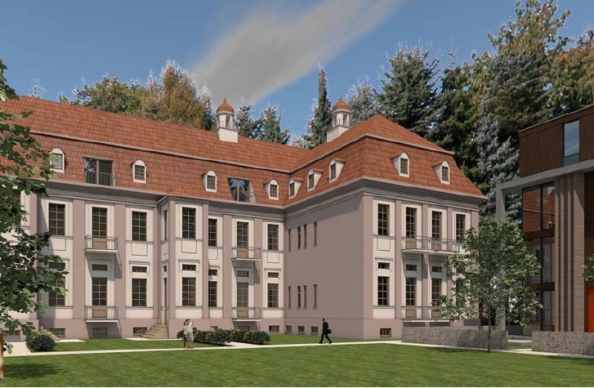● planned new use nursing home

-

-

-
-



WALDHAUS BUCH
residential and nursing home

EXPOSÈ

PURCHASE PRICE 11 mil.
€

PLOT AREA A 20.000 m²
existing building (WALDHAUS) (NGF) app. 9.000 m² new building extention(WALDHAUS) (NGF) 4.128 m²
TOTAL(WALDHAUS + EXTENTION) (NGF) 13.128 m²
Construction costs 16 mil €
TOTAL project costs 27 mil €
Lease contract for 20 years 2,2 mil € per year
equity 11 mil €

Bank financing 16 mil €
PLOT AREA B 30.000 m²
AREA useable (NGF) 23.277 m²
land value (150 € x 23.277m²) 3.491.550 mil €
SUMMERY

The project has two components:

- nurisng home (plot of 20.000 m²)
- building plot (plot of 30.000 m²)

- The purchase price of 11 mil € is for boths plots

- It is possible to sell the plot B and to reduced the equity to around 6.5 mil €

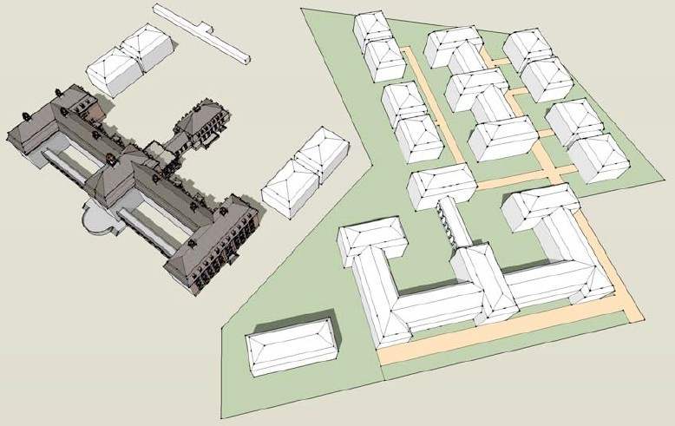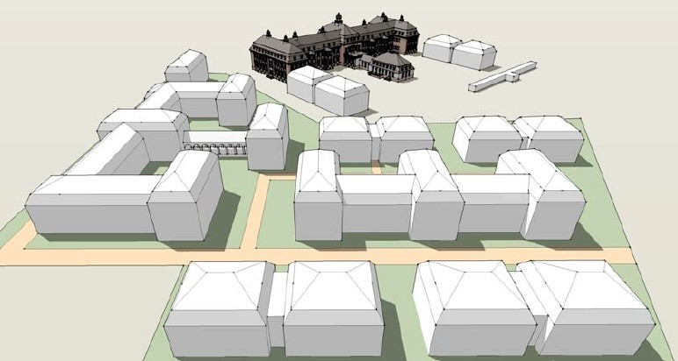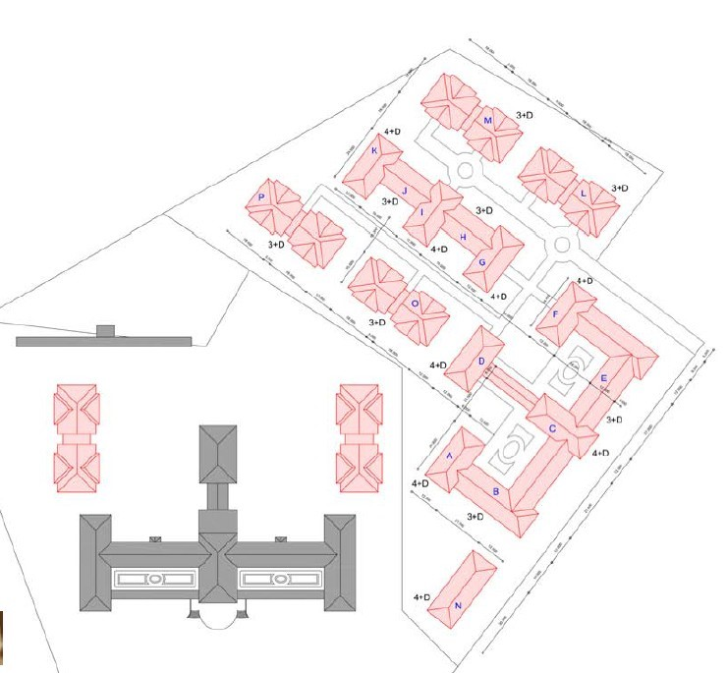

planning

preview

PLOT A

PLOT B

preview

location | 
location | 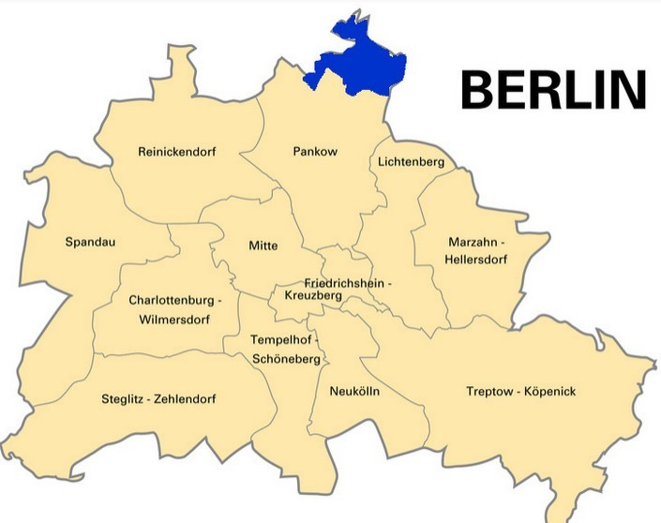  The project is located on the northeastern outskirts of the district Pankow, in the district book.  Science, Health, housing and plenty of nature - this featuring book in a few words.  The scientific field is particularly strong pronounced. Finally, here is more than 80 Years research for health. On one of the find areas largest hospital in Germanya number of institutions that deal withemploy medical scientific research. These include the Max Delbrück Center for Molecular Medicine (MDC), the Research Institute for Molecular Pharmacology (FMP), the Genome Research Institute and many businesses biotechnology. Moreover, in book a plurality of medical facilities and To find hospitals, among others the Helios Kliniken, the Rheumatology Clinic Berlin-Buch and others.

impressions

impressions | 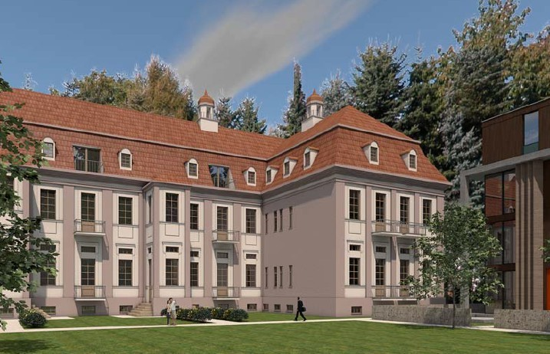  Preview Nursing home with the „old“ Waldhaus  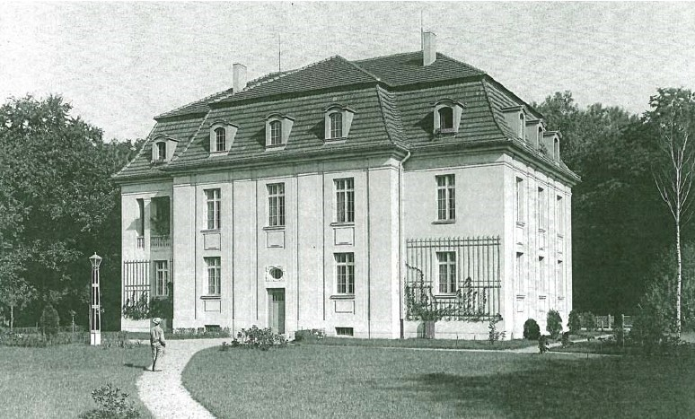  Officials house around 1905

impressions

impressions | 